**System analysis**

System analysis was done in order to completely understand the application that will be developed. The gathered information will help to create logical models so that we can code the application to satisfy our goals. The large complex project was broken into small manageable parts so each may be designed, studied and analyzed in detail. The tools used will help to transform requirement specification into implementation. UML has been used as visual modeling language. Some of the tools used are **Use case diagram for analyzing functional requirement**, **ER diagram for data modeling technique and Context diagram for process modeling**

**Use case diagram**

It provides concise summary of what the app should do at abstract level. The expected behavior of the app has been specified. Here, Xplitter-Expense Splitter Application is an app that will be developed. User and system admin are actor that will use the app. There are list of use cases that captures the requirements that the actors want to achieve. User being in the left is the primary actor who initiates the use of the app. System admin being at right is our secondary actor who reacts only when user does something like here when user login, system admin authenticates.

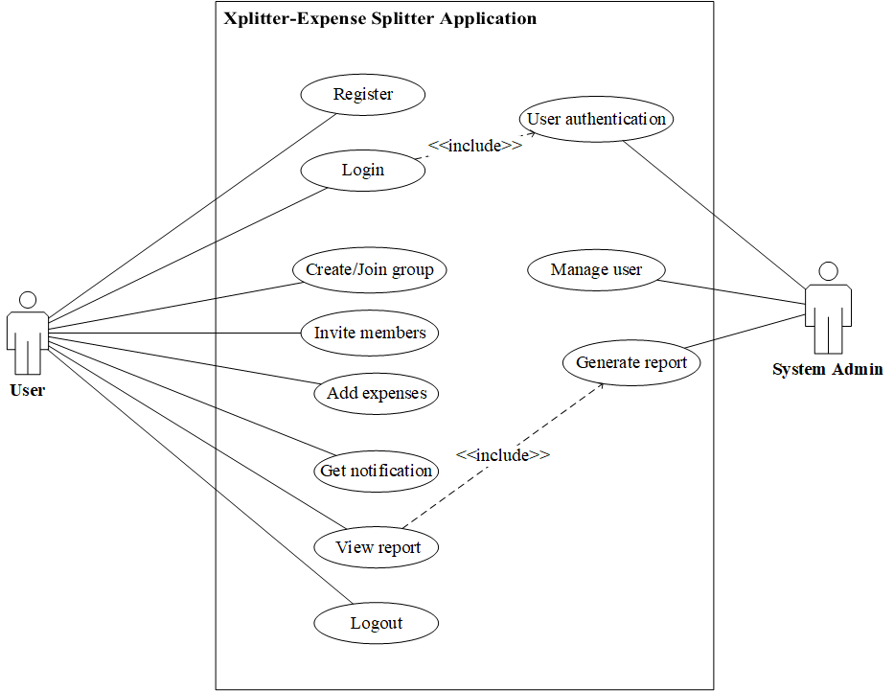

**ER diagram**

Here Chen’s Notation is used to draw the ER diagram. Constructing ER diagram helped us to visualize our database for our App. Here we can see entities are User, Groups, Expenses and Notification which will be the tables that we will make in database in order to store data. Their attributes are the properties that will describe the entities i.e. the columns of table that we need to describe each tables and relationship between entities are showing how these entities or tables in database will be linked together.

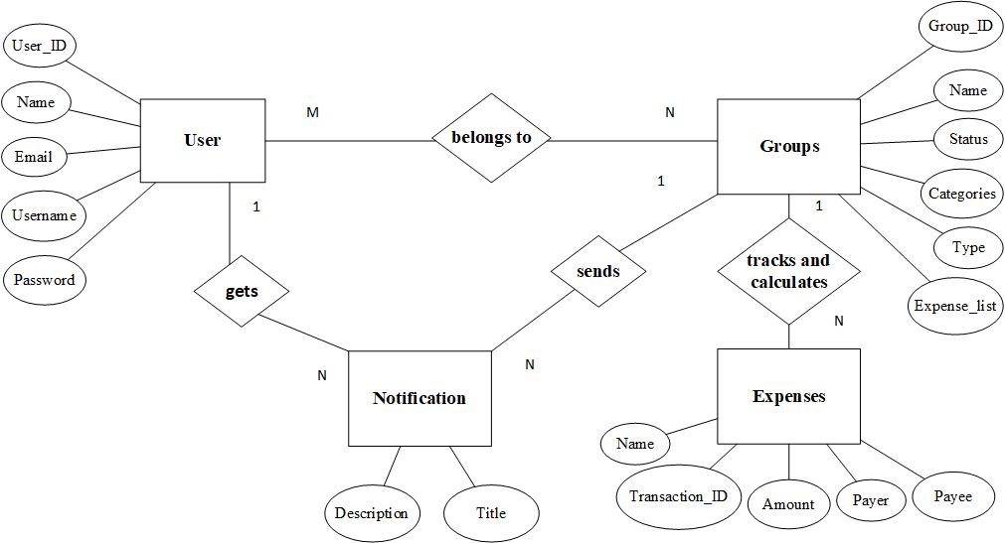

**DFD**

